PLANT SOURCED RANDOM CARRIER WAVE GENERATION FOR

MOTOR DRIVE WITH BETTER EMI

**Abstract**

In conventional motor drive systems (Sine PWM or SV PWM) use a carrier signal for driving the inverter. Frequency of the carrier signal is actually working frequency of the inverter. Conventional inverters contain six switches as three of them upper and other three ones are lower switches. According to inverter switch type (Mosfet, IGBT, ICT, SiC, GaN etc.) the characteristic of switched signals are effected (Voltage and Current of the motor phases) by switch specifications (such that t_on, t_off times, Rds_on). So this specifications causes some random small peaks on the phase voltage and currents. Also harmonics on the voltage and currents are another issue for drive systems and conventional techniques can limited these effects with high frequency (ex. 70-100k) drive. In this time, driver needs more process capability and mechanical noise of motor increases as vibration. In this work, the plant sourced modulation technique is detailed and suggested.

**1.Introduction**

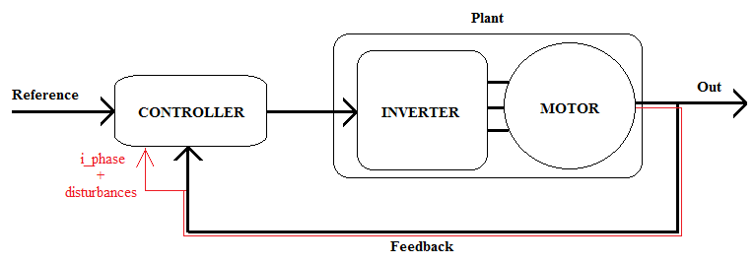

**2.Thoery**

**2.1. Conventional Design**

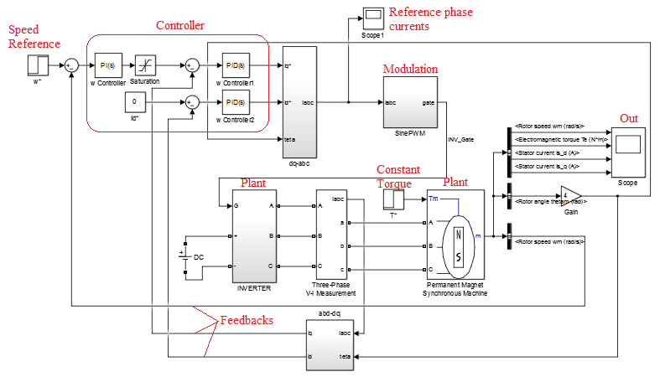Conventional Motor Drive System – Simulink Blocks

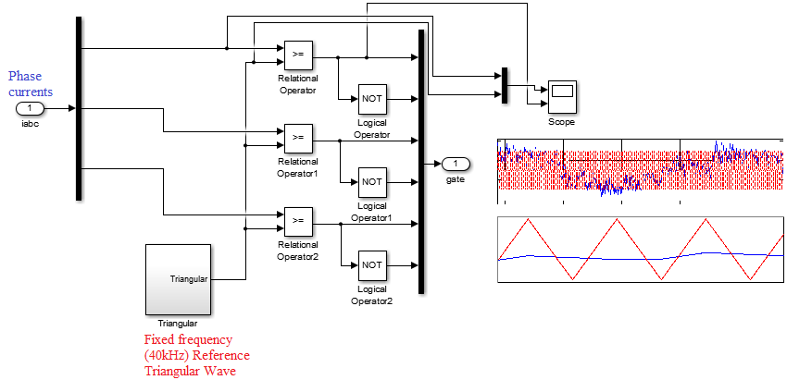Extension of Conventional SinePWM Block

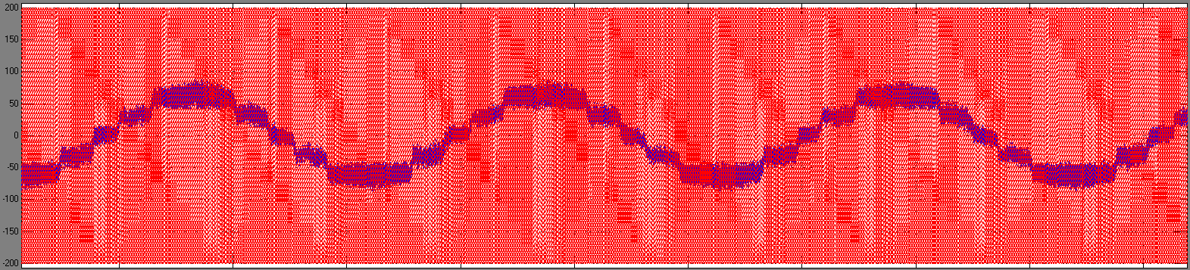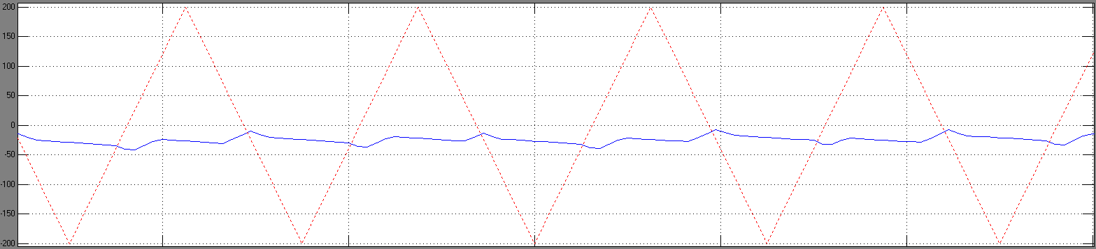

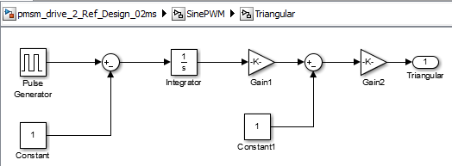 Fixed 40kHz Triangular Carrier Generation (Vpp 400V)

**2.2. Random PWM Technique (Exist in the literature)**

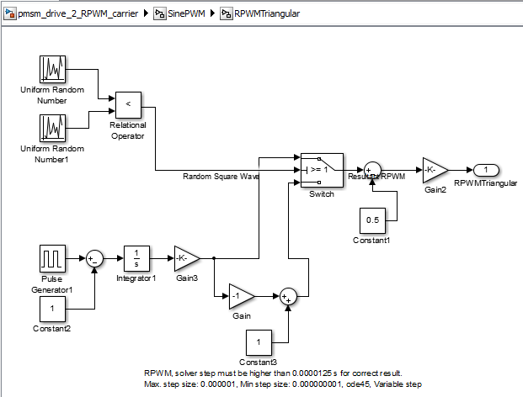

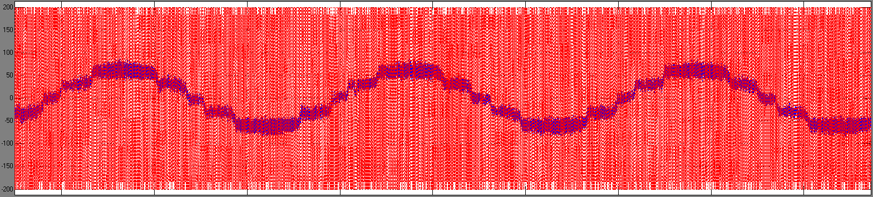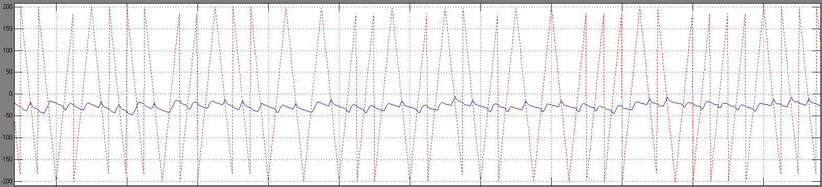

**2.3. Plant Sourced Random PWM Technique**

The phase currents have some random ripples. We choose one of the phase current in drive system (ex. Phase B). We measure the instant value of it and compare with its 3-5 step previous value (memory blockes in the simulation). Since, the ripples sourced by randomly process (small differences t_on, t_off times) of IGBT operation, the comparison creates randomly changed carrier wave form with fix frequency. According to memory block number, harmonic suppression graph (FFT) changes.

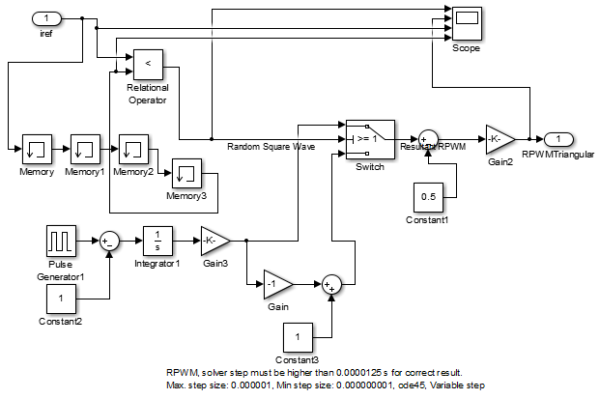Extension of Motor phase current sourced RPWM carrier

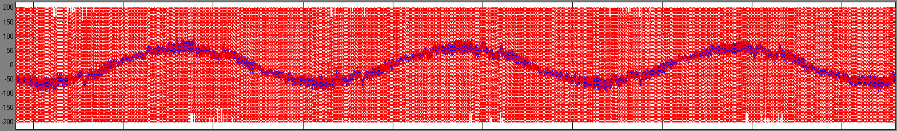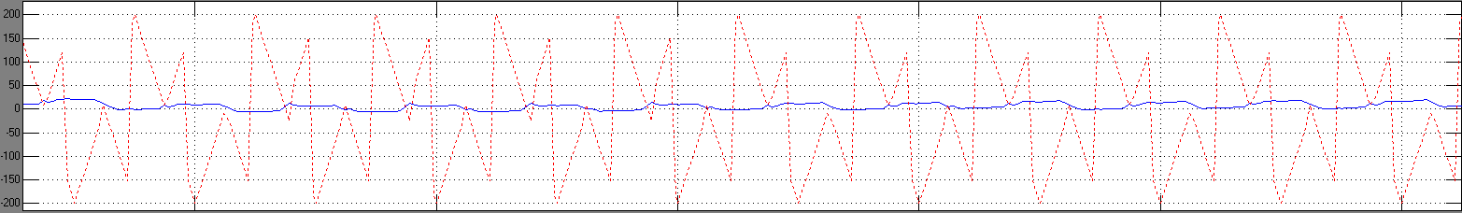

**3. Results**

**3.1. Conventional Design**

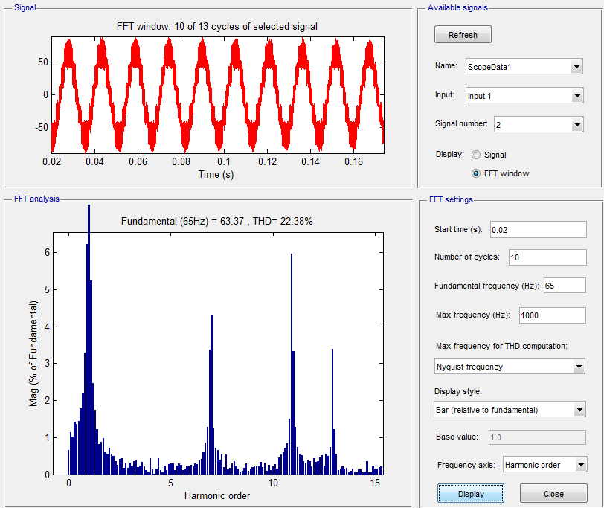

Reference Design (40kHz Triangular Carrier, Solver: Variable ode45 min step: 1e-7, max step: 1e-6)

**3.2. Random PWM Technique (Exist in the literature)**

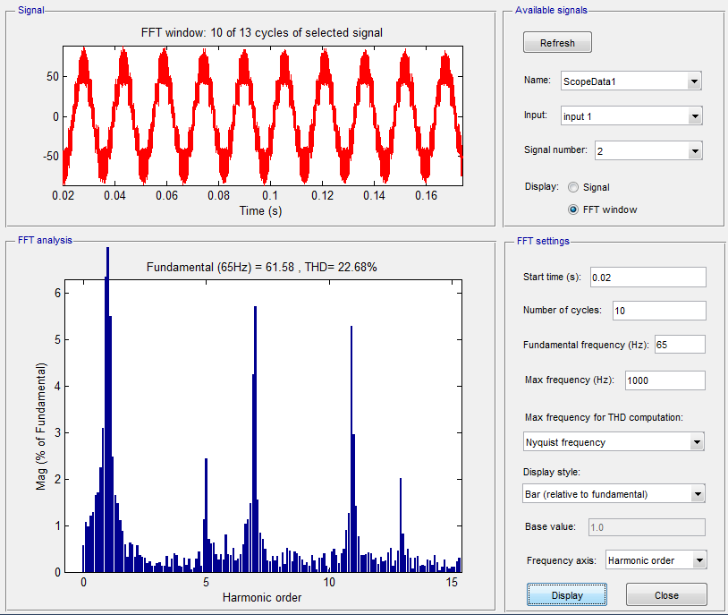

RPWM design (exist in literature) (40kHz Randomized Triangular Carrier, Solver: Variable ode45 min step: 1e-7, max step: 1e-6)

**3.3. Plant Sourced Random PWM Technique**

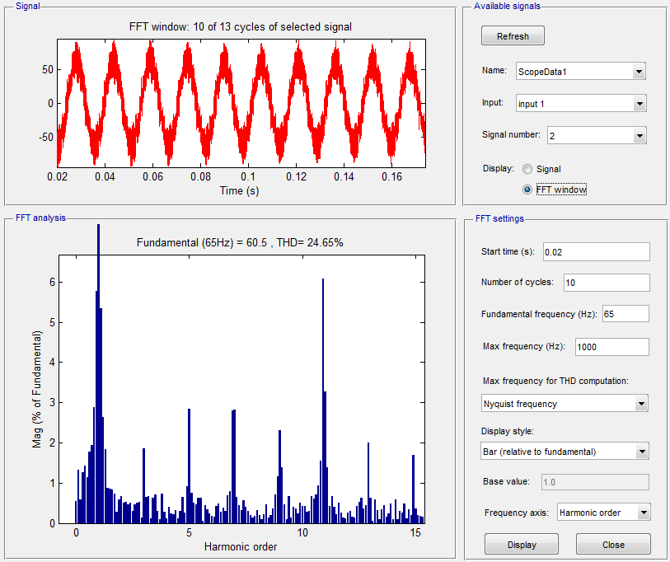

Plant Sourced RPWM with 4 memory block (40kHz Plant Sourced Carrier, Solver: Variable ode45 min step: 1e-7, max step: 1e-6)



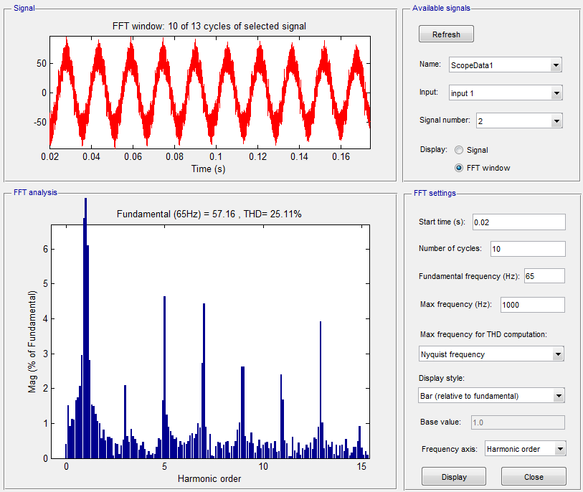

Plant Sourced RPWM with 5 memory block (40kHz Plant Sourced Carrier, Solver: Variable ode45 min step: 1e-7, max step: 1e-6)

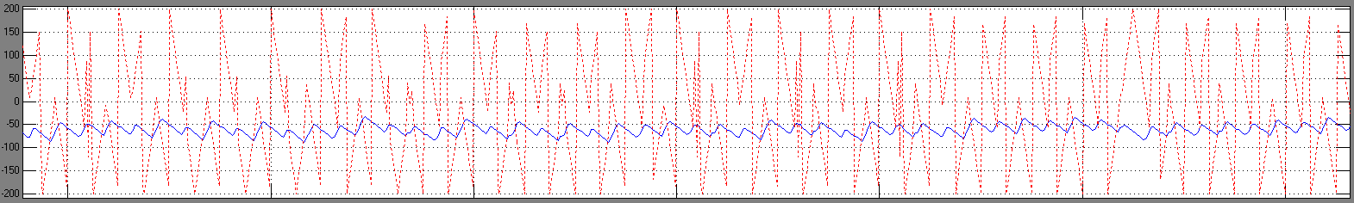

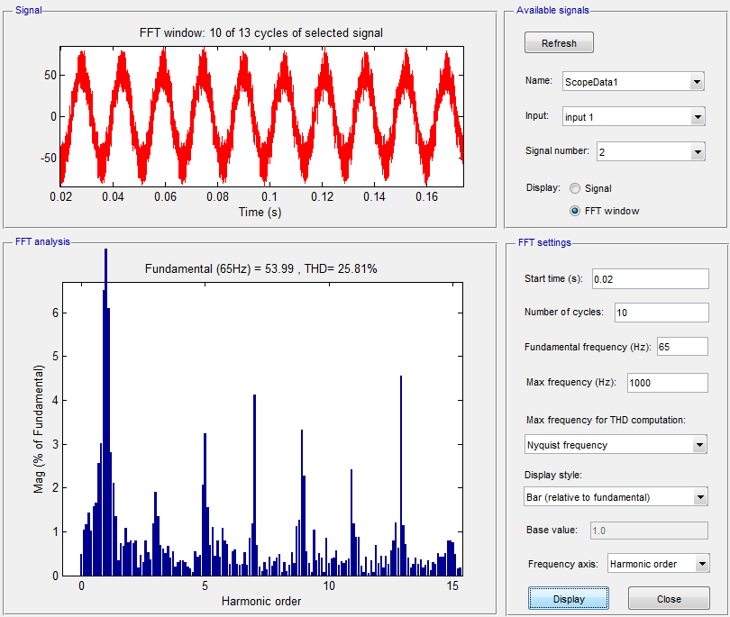

Plant Sourced RPWM with 6 memory block (40kHz Plant Sourced Carrier, Solver: Variable ode45 min step: 1e-7, max step: 1e-6)

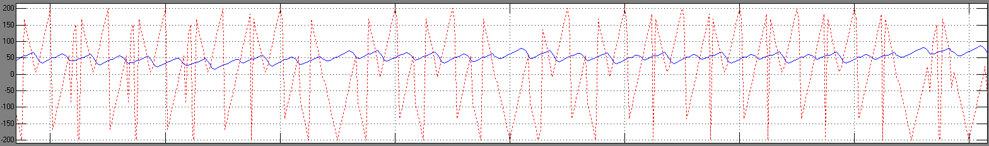

**Advantageous**

**-5,7,11 .. harmonics suppressed – balanced (EMI)**

**-No need Random Number Generator function (Easy Implementation)**

**-Be able to set according to product EMI needs**